Picture  Move the L, F and Fulcrum icons and place them in the correct position on each diagram as shown in the first example. | Lever Type  (1st, 2nd or 3rd ) | Advantage Type  (Force or Speed/Distance)

E
FFF
L
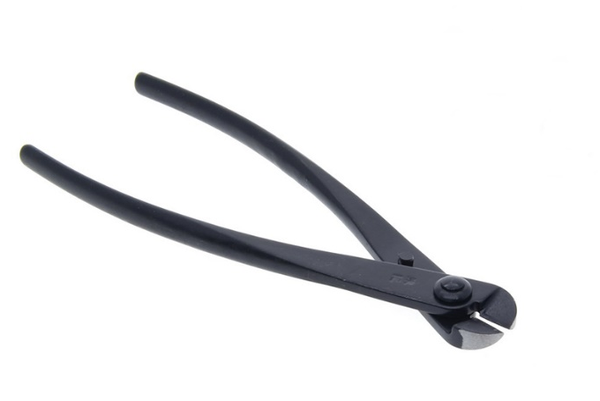
FFF
E
L
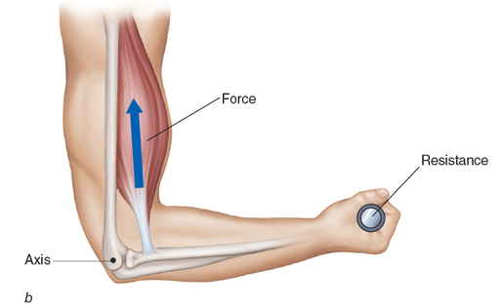
L
E
FFF
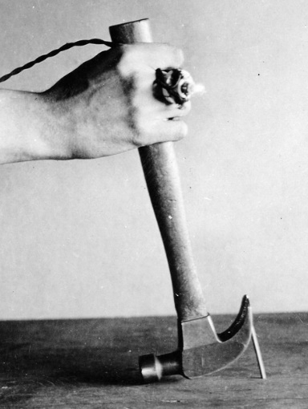
L
E
FFF
Picture | Lever Type  (1st, 2nd or 3rd ) | Advantage Type  (Force or Speed/Distance)
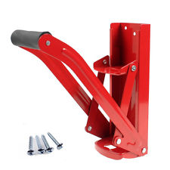
FFF
E
L
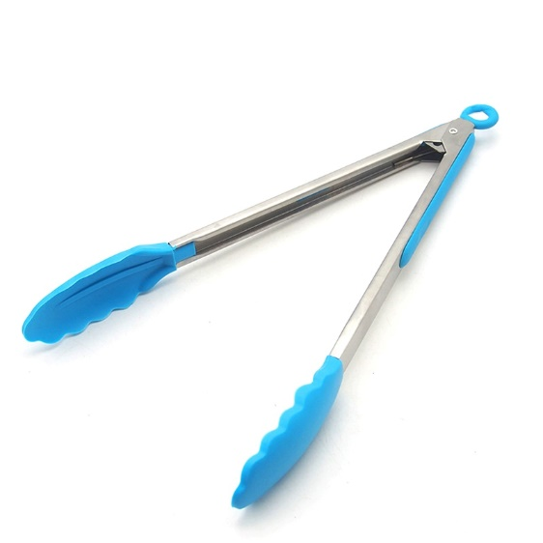
L
E
FFF

FFF
E
L
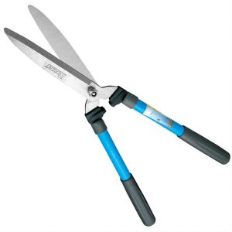
FFF
E
L
Picture | Lever Type  (1st, 2nd or 3rd ) | Advantage Type  (Force or Speed/Distance)
L
FFF
E
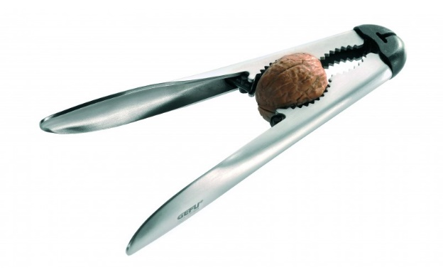

L
E
FFF
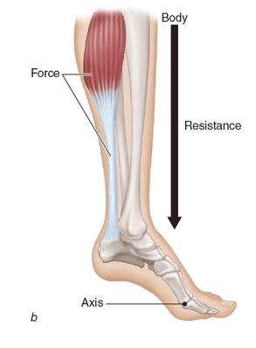
L
E
FFF
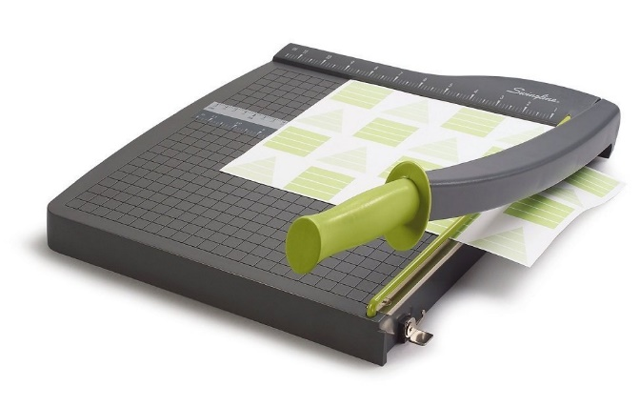
L
E
FFF
Picture | Lever Type  (1st, 2nd or 3rd ) | Advantage Type  (Force or Speed/Distance)
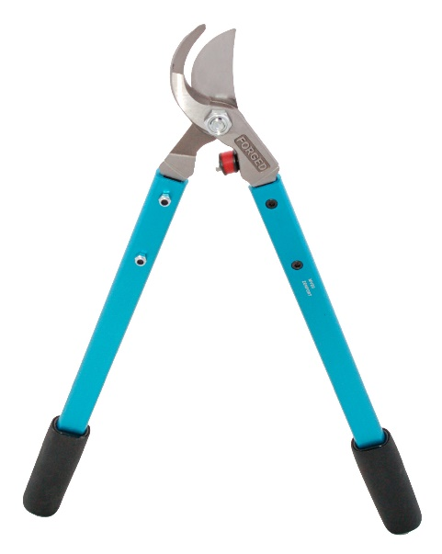
L
E
FFF
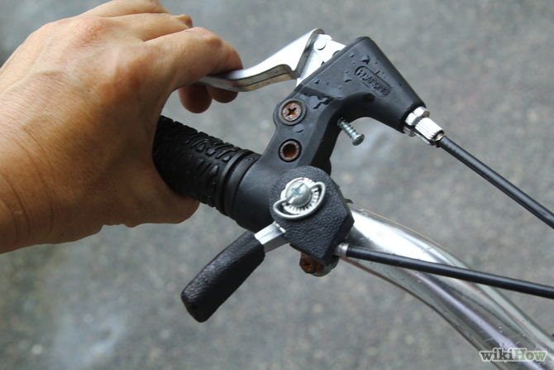
L
E
FFF

L
E
FFF

L
E
FFF
Picture | Lever Type  (1st, 2nd or 3rd ) | Advantage Type  (Force or Speed/Distance)
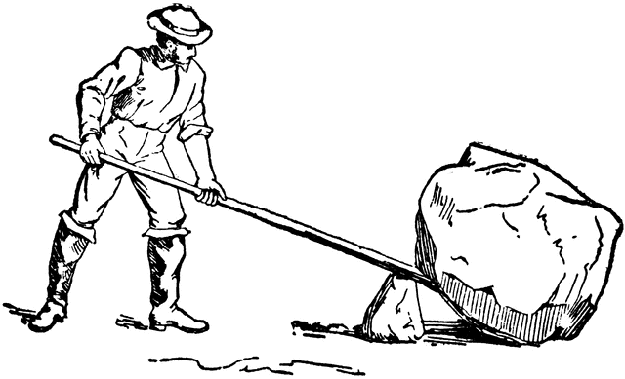
L
E
FFF
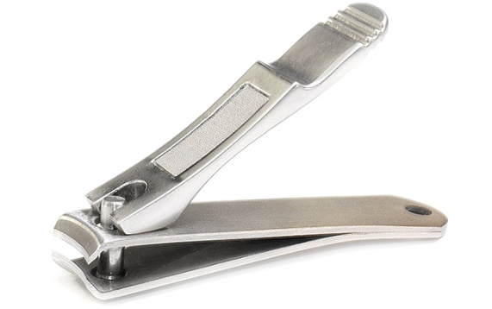
L
E
FFF

L
E
FFF
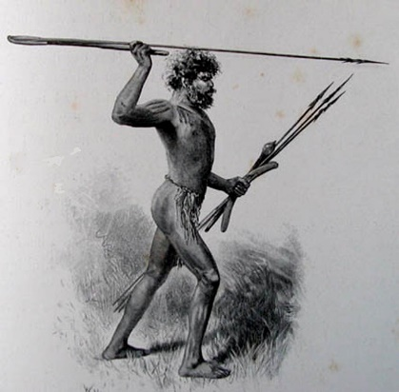
FFF
E
L

